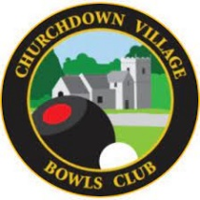
B CHURCHDOWN VILLAGE BOWLS CLUB
EMERGENCY INFORMATION

This information is collected from the parents of any under 18-year-old child that wishes to join Churchdown Village Bowls Club and must be completed at time of registration.
[PLEASE PRINT ALL DETAILS]
NAME OF CHILD: _________________________________________
MEDICAL PROBLEMS: _________________________________________
___________________________________________________________________
___________________________________________________________________
___________________________________________________________________
___________________________________________________________________

ALL MEDICATION THE CHILD IS TAKING:
___________________________________________________________________
___________________________________________________________________
___________________________________________________________________
___________________________________________________________________
___________________________________________________________________

NAME OF EMERGENCY CONTACT:
___________________________________________________________________
TELEPHONE NUMBER:
___________________________________________________________________

